PSCommander (CS2)

Setup

PSC Commander is mainly made for the use with a Tablet, but it could also be an option to use it with a mouse. Independent from the used input device it is needet to setup the used Hotkey Buttons for your Device and to Change your the Photoshop Keys for F2, F3 and F4 if they were used.

The following is the suggested Configuration:

Key Konfiguration (Mouse)

F2 - 4. Mouth Button/Tablet - Lower Pen Button)
F3 - 5. Mouth Button
F4 - near your second Hand...

Key Konfiguration (Pen Tablet)

F2 - Lower Pen Button
F3 - Upper Pen Button
F4 - One of the Express Keys

Using the Settings.ini

I have tried to make all Buttons/Shortcuts/Buttonlabels customizable and actually it should work, but for an amateur “Programmer” this isn't so easy..

Important is to mention that the Settings use the same Code for Key modifiers as Autohotkey does.
This are:

Shift = +
Alt = !
Ctrl = ^

If you want to change a shortcut you have to use these Symbols instead of Ctrl or Alt.
Example:

Shortcut: Shift+Alt+F2 = +!F2 or = +!{F2}

The Layout Buttons

In the Settings.ini you can define the x/y coord where the GUI's should appear in the layout, together with a shortcut for a saved Photoshop Layout, which is activated through a shortcut you have to define inside PS.

The Executable Buttons

The executable Buttons activate the Run command for anything you define in the Settings.ini. This could be any file or executabel software or a folder to open or an URL. Surely this files or folders will open via your defined standard programs (file explorer/browser). The Files can be on any location of your system/harddisc. If you place them into the Scripts folder, you have just to enter the name of the file in the Settings. For any other location you have to enter the full path to the file/folder.

The Guide Functions

The Guide Scripts are very simple. They call for a function that is located in the same folder and should not be changed until you know what you are doing... But you can change the
Scripts (.jsx) on your own if you want. You need an application that can open the Scripts for editing (e.g. Notpad++) - Every line activates one horizontal or a vertical Guide in a
defined percentage of the actual document. Just take a look the code - It's self-explanatory...

Photoshop Shortcuts

I have tested the Tool with the US Default Version of the Photoshop Shortcuts (.ksys). But the following Shortcuts I used are not in the Default Settings.

Action | PSCommander Default (Settings.ini)
Duplicate Layer (Layer Menu) | Ctrl + Shift + Alt + NumDivide ( / )
New Snapshot (Protocol Palette) | Ctrl + Shift + q
Selection by Color (Selection Menu) | Ctrl + Shift + Alt + `
Snap to Guides (View) | Ctrl + Shift + =

To use this Actions with PSCommander you have to setup these Shortcuts in Photoshop or alternatively you can use the US-PSC.ksys

Compatibility

If you want to use PSCommander with custom Shortcuts or other Keyboard Layouts you have to adjust the Settings.ini to your configuration.

Other Photoshop Versions

For other Versions of Photoshop applies the same as above. Additionally the included Javascripts that are actually part of some internal features may not work correctly. Unfortunately I could not test this.

The Main GUI

Move the Window by grabbing the lower or the upper Border.

Copy/Paste | Ctrl+c / Ctrl+v
Snapshot | Protcol Snapshot
New Layer | Add a new Layer (no Dialog)
Duplicate/Merge/Stamp | Commonly known Layer Actions
Clip Mask | Activate/Deactivate the Layer Clip Mask
Select Color | Color Selection Dialog
Layout1/Layout2 | Define Window Positions together with Photoshop Layouts.
Snap on/off | Toggles Snap to Guides Function
Guides on/off | Toggles Guide visibility
Select Pixels | Runs the SelectPixels.jsx (you can change this in the Settings.ini to run or open any other file or folder located in the Scripts Folder)
Help | Opens the Help.pdf
Normal/Erase/Behind/Overlay/Burn | Mode Shortcuts
Custom 1-7 | Executable Buttons (Run or Open a folder/file/url)
Guides | Opens the Guides folder, inside this Folder you see some javascripts that do pretty simple Guide Actions
Color Picker | Activates another Autohotkey Script i have written - a simple Color Picker
Exit | Guess what it does ;)

The Brushcontroller

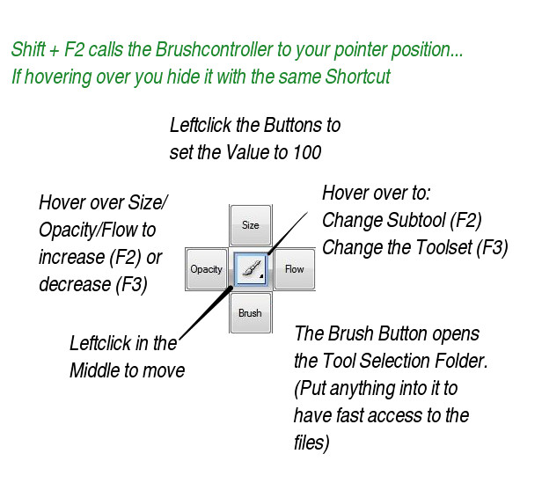
Brush Mode (Blue)

Selection Mode (Green)

No Hover Over Functions
Click on the Buttons to Activate Transform/Stroke/Fill/Selection to Path (Automatically changes to the Path Mode..)

Path/Shape Mode (Red)

No Hover Over Functions
Click on the Buttons to Activate Transform/Stroke/Fill/Path to Selection (Automatically changes to the Selection Mode..)

